Join us as we watch, The Euthanasia Deception, a one-hour documentary featuring powerful testimonies from Belgium and beyond of lives devastated by the false ideology of ‘mercy killing’.

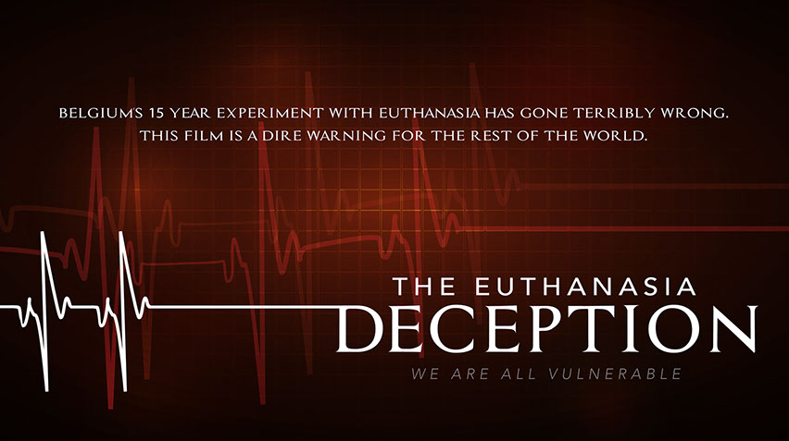
See first-hand about what happens when physician assisted suicide [euthanasia] becomes legal . . .a threat that Maryland has faced for the past three years.

Learn what you need to know to help prevent physician assisted suicide from being made legal and how you can prevent it from becoming a reality in Maryland.
EVENT INFORMATION

Date: Tuesday, September 26,
2017
Time: 7:00pm to 9:00pm

Location: Harvest Baptist Church 29945 Dixon Rd
Salisbury, MD 21804
Nutters Crossing Community
off Rt 12
For more information please contact: Paul Okerblom
410-713-9106

Hosted by the Maryland March for Life
www.mdmarchforlife.com

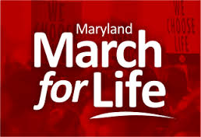

For additional details about the documentary, please visit vulnerablefilm.com or caringnotkilling.com.

